# ISRC-CN3 Autumn School Day 3 (26th October 2022)

**Topic:** Investigating time series neural data: Experimental design & processing

# Experiment Description:

The neural signals were recorded using a TMSI Refa8 EEG amplifier at a sampling rate of 256 Hz from 17 electrode locations in the fronto-central, central, centro-parietal, and parietal regions (arranged in a standard 10-20 configuration), namely, Fz, FC3, FCz, FC4, C5, C3, C1, Cz, C2, C4, C6, CP3, CPz, CP4, P3, Pz, and P4. The left ear mastoid was used as a reference electrode, while the right ear electrode was used as the ground electrode. The EEG recording, display of visual cues, feedback, and online classification of the motor imagery tasks were conducted using OpenVIBE software.

Sixteen naive participants (13 male and three female, with a mean age = 28 ± 9 years) volunteered for this study. The participants performed the cued motor imagery tasks using their left hand, right hand, left foot, and right foot. Each participant from the FES and VIS groups underwent a single training session followed by three feedback sessions. Each session consisted of 24 trials for each motor imagery task. **You will only work with subjects indexed 15, 16, 17 and 18.**

The visual cues (Fig. 1) were displayed in the following sequence. At the beginning of each trial, a fixation cross was displayed on the screen for 1s. Motor imagery instructions were then provided for 1s in the form of arrows. The sequence of arrows was as follows: a left/right arrow to indicate motor imagery on the left/right side, followed by an up/down arrow to indicate whether to move the hand or foot. For example, if a right arrow was displayed followed by a down arrow, then the participant must imagine moving the right foot. The instruction cues were followed by a feedback period of 4s in the form of visual or somatosensory feedback. There was a delay of 500ms in the projection of the feedback (that is, the display of a feedback bar or the relay of electrical stimulation) owing to the computations involved by the online decoder. Finally, after the feedback period, a blank screen was displayed for 2.5-3.5s, allowing the participants to relax.

While the participants were conducting the experiment, continuous streams of EEG signals were recorded using Openvibe software. The continuous EEG signals were segmented into lengths of 5s epochs, starting from 1s before the onset of the feedback period of each motor imagery (MI) task. Each epoch was then filtered using a fourth-order Butterworth band-pass filter at [.5,40]Hz and re-referenced at Fz. Finally, log-transformed variances of the first and last spatial filters were computed using common spatial patterns (CSPs) to extract the feature vectors. These feature vectors were used as inputs to a multi-class linear discriminant analysis (LDA) classifier. The classifier (in Openvibe) predicted the outcome of the motor imagery task conducted by the participant during each trial in the form of output labels and confidence.

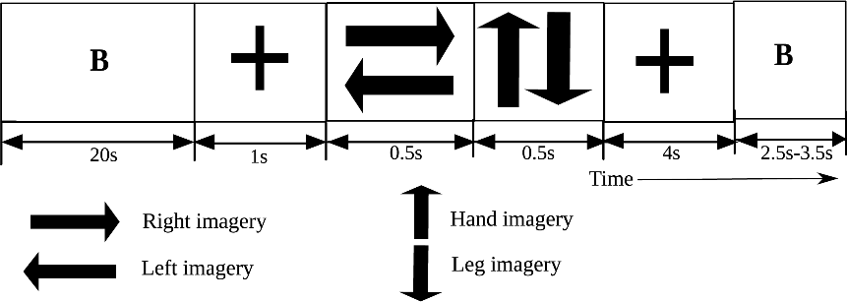

Fig. 1 Sequence of visual cues displayed to the participants during the online neuro-feedback experiment.

To detect erroneous trials in the form of ErrP signals, we re-labelled the trials with correct feedback (produced by the online BCI) as *correct* or -1, whereas the trials with incorrect feedback were labelled as *incorrect* or 1.

Dataset Description:

* subject_XX.mat: Epochs of each subject, where XX is 15, 16, 17 and 18. The epochs are arranged in the following format: *no_samples × no_channels × no_trials*.
  + Sampling rate: 256
  + Epochs: 0-6 seconds; total length of epoch is *256 × 6 = 1536*

o Channels used: 'FC3', 'FCz', 'FC4', 'C5', 'C3', 'C1', 'Cz', 'C2', 'C4', 'C6', 'CP3', 'CPz', 'CP4', 'P3', 'Pz', 'P4'

* + Total number of trials: 96

To load the epoched data, just double-click on the(‘subjectXX.mat’). Change XX into the appropriate subject number.

* labels.mat: Correctness of all four subjects, where ‘correct’ is labelled as -1 and ‘incorrect’ is labelled as 1.

A Matlab live script file is provided (AutumnSchool_Day3_SB_Exercise_Solution.mlx) that will help you complete the exercises below:

# Exercises:

1. Temporal filter: Apply a low-pass filter of your choice with a cut-off at (a) 6Hz and (b) 32Hz
2. Plot a sample of the filtered for (a) and (b)
3. Plot Raw EEG for (a) and (b)

compare the differences.

1. Spatial filter: Apply a Laplacian filter for the following electrodes: FCz, Cz and CPz
   1. Plot a sample of the filtered and raw EEG to compare the difference
2. Baseline correct the (a) temporally and (b) filtered data. Use (a) 100 ms and (b) 500 ms before the stimuli onset to baseline correct the data. Use the figure above to select the sample points.
3. Plot the grand averages of the electrodes: Cz, FCz and CPz for the time range [1.5, 3] s, where 1 is the onset of the feedback period.
4. Plot and analyse the time-frequency distribution of the (a) temporally and (b) spatially filtered signals using Morlet Wavelet. Discuss your observation with your lab tutor or partner.